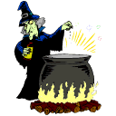
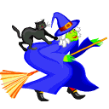
A witch took your spelling words and mixed them up to make a spell. To break the spell, you need to put your words back to their correct spelling!

1.) p a ge ___________________

- ke j o __________________

- e ll j y ______________________

- i ll y s _______________________

- m a j __________________________

- ea j n s _______________________

- s c e n s t _________________________

